CURRICULUM VITAE

Manas kumar panda
Mobile: 6371985608
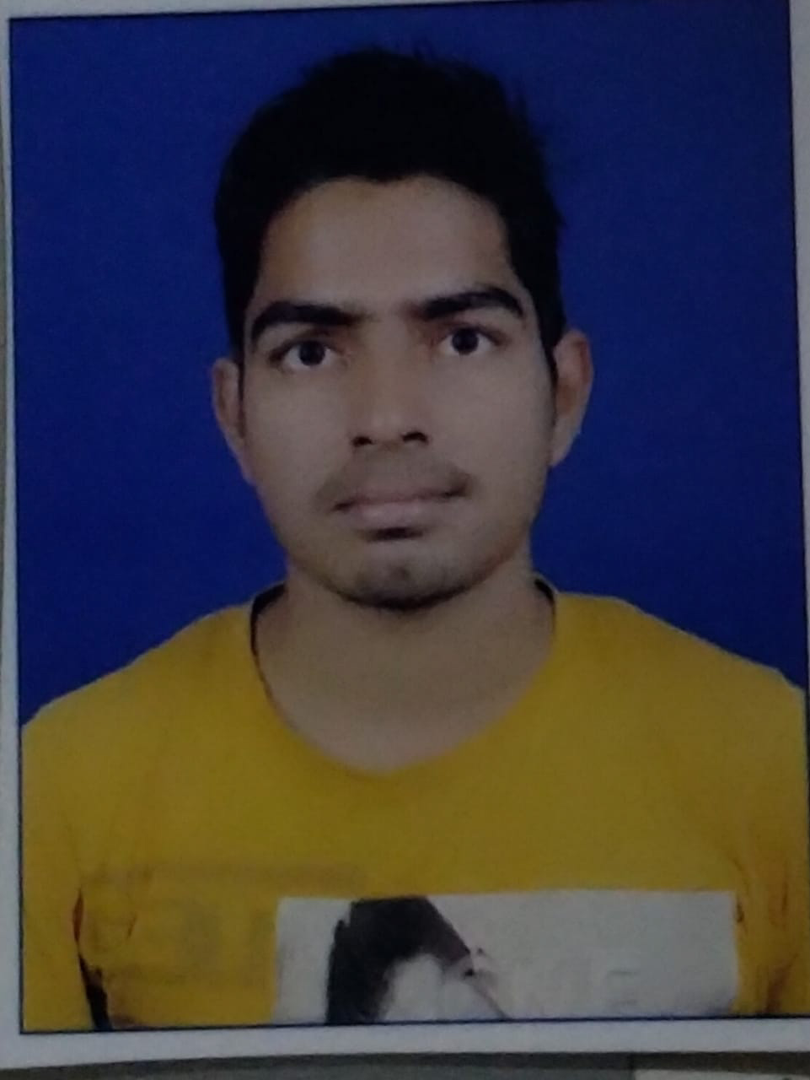
Email-id-manaspanda0852@gmail.com
Bhadrak,odisha

Objective
To Obtain a challenging career in the IT industry and put all my efforts into the growth of the organization and have a great working environment.
Education
- SATYA SAI ENGINEERING COLLEGE,BALASWAR(BPUT,ODISHA)

(2022) 5th sem CGPA-8.77

- +2 science Ghanteswar jr Mahavidayalaya Ghanteswar. (2018)

- 10 th Giridhari panda ucha vidya pitha (Manjuri road)(2016)

Technical Skill

- Post Graduate Computer In Application (P.G.D.C.A)
- Java
- HTML 5
- CSS3

PROJECT
- NAME:visa dispensation system.
- LANGUAGE-java.
- Framework-j2ee.

Interests
- Reading Newspaper & Books.

- Playing Football & Cricket.

Personal Strength

Hardworking, adaptability to situation, Possessing high patience, love to work in team.

Personal Profile
Father’s Name : Rabindra panda
Permanent Address : At/ Po – Manjuri road
Ps-Manjuri road
Dist-Bhadrak
Pin-756121
Location-bangalore

Date of Birth : 05 february 2000
Nationality : Indian
Religion : Hinduism
Sex : Male
Category : general
Marital Status : Unmarried
Languages : Oriya, Hindi & English

The above particulars are true to the best of my knowledge and belief.

Place:
Date: Signature

